

TITLE PAGE
DEVELOPMENT OF AN INTELLIGENT REPOSITORY FOR ENHANCING ORIGINALITY IN FINAL YEAR UNDERGRADUATE PROJECTS

BY

ABDULLAHI MUBARAK
(U21CS1006)

A PROJECT SUBMITTED TO THE DEPARTMENT OF COMPUTER SCIENCE, AHMADU BELLO UNIVERSITY, ZARIA-NIGERIA IN PARTIAL FULFILMENT OF THE REQUIREMENTS FOR THE AWARD OF THE DEGREE OF BACHELOR OF SCIENCE (B. Sc. Hons.) IN COMPUTER SCIENCE

SEPTEMBER, 2026

DECLARATION

I, ABDULLAHI MUBARAK, hereby declare that this project titled DEVELOPMENT OF AN INTELLIGENT REPOSITORY FOR ENHANCING ORIGINALITY IN FINAL YEAR UNDERGRADUATE PROJECTS has been carried out by me under the supervision of MALL. I. E. UMAR. It has not been presented for award of any degree in any institution. All sources of information are specifically acknowledged by means of reference.

_______________ _______________
Signature Date

CERTIFICATION
This project entitled “DEVELOPMENT OF AN INTELLIGENT REPOSITORY FOR ENHANCING ORIGINALITY IN FINAL YEAR UNDERGRADUATE PROJECTS” by ABDULLAHI MUBARAK meets the requirements governing the award of the degree of Bachelor of Science in COMPUTER SCIENCE and is approved for its contribution to knowledge and literary presentation.

_________________ _____________
Mall. I. E. Umar Date
Supervisor

_________________ ______________
Prof. A.F Kana Date
Head of Department

External Examiner
Name: _______________________ _____________
Signature: ________________ Date

DEDICATION
I would love to dedicate this project in its entirety to the one who has been my biggest source of motivation since the beginning of my undergraduate degree up till the very end. Even though you were not able to witness it all in person, your presence was felt throughout the journey. To my late brother, ABDULLAHI JAMIU.

ACKNOWLEDGEMENTS
To begin with, I would like to thank almighty Allah for guiding all my steps, protecting me, making the journey a smooth one and sparing my life throughout the course of this degree.
And to my parents, thank you for all your support either emotionally, financially, morally and all other ways. May God almighty reward you in this world and the hereafter, and may you reap the fruits of your labor.
To my siblings Muibat, Abdulmuiz and Majeedat Abdullahi, you all are the best siblings I could ever ask for. May we all grow old and do great things together. I love you all and I promise to make you proud.
I really couldn’t have completed this degree without my course mates and also my friends by my side, AbdulSalam, Abdulmalik (Halal Boy), Murtada, Sadiq, Sulaiman (GRA) and Riskiyya, I can’t ask for better friends than you all. Thank you all for being with me when the journey was the toughest.
I also want to thank my supervisor Mall. I.E. Umar for his supervision and support in making this project a successful one. On the same note I want to thank all my lecturers for all the knowledge earned from them throughout the course of this degree.
This won’t be complete without acknowledging the absolute love of my life Hameedah Ayomide, you stood strong by me from the beginning of the journey till the very end. I appreciate you a lot and I love you so much.
And to myself, Mubarak Olalekan Abdullahi, congratulations you did it and I’m proud of you, may the journey ahead be blessed. You will do great things in life.

ABSTRACT
The development of an intelligent repository system for enhancing originality in final year undergraduate projects addresses the challenge of accessing previous projects and identifying similarities between proposed project topics and existing undergraduate works. The study developed a web-based repository that provides a centralized platform for storing, managing, searching, viewing, and retrieving approved final-year undergraduate projects. The system was implemented using Python and the Django web framework, with SQLite used for database management and HTML, CSS, and JavaScript used for the user interface. Students can register, authenticate using their email address or matriculation number, submit projects for administrative approval, and access approved projects, while administrators manage project approval and repository activities. An intelligent originality analysis component was also implemented, specifically Term Frequency-Inverse Document Frequency (TF-IDF) and cosine similarity, to compare proposed projects with approved projects in the repository. The analysis examines the title, keywords, and abstract, calculates weighted similarity scores, ranks related projects, and provides an explanation of the strongest similarity area. The developed system provides a centralized repository and an intelligent mechanism for identifying repository-based textual similarities, thereby supporting students in reviewing and refining proposed final-year project ideas.

TABLE OF FIGURES
Figure 1 System Architecture 25
Figure 2 Originality Checker Framework 27
Figure 3 Students Registration Page 32
Figure 4 Students Login Page 32
Figure 5 Student Dashboard 34
Figure 6 Project Submission Page 35
Figure 7 Project Approval Page 36
Figure 8 Repository View 37
Figure 9 Project View Page 37
Figure 10 Originality Checker` 38
Figure 11 Similarity Check with Low Similarity 52
Figure 12 Similarity Check With Moderate Similarity 52
Figure 13 Similarity Check With High Similarity 53
Figure 14 Repository Search 53

TABLE OF CONTENTS
TITLE PAGE i
DECLARATION ii
CERTIFICATION iii
DEDICATION iv
ACKNOWLEDGEMENTS v
ABSTRACT vi
TABLE OF FIGURES vii
TABLE OF CONTENTS vii
CHAPTER 1 1
INTRODUCTION 1
1.1 Background of study 1
1.2 Statement of the Problem 2
1.3 Aim And Objectives 3
1.4 Scope of the Study 3
1.5 Limitations of the Study 5
CHAPTER 2 6
LITERATURE REVIEW 6
2.1 Concept of Digital Repositories 6
2.2 Undergraduate Project Management Systems 7
2.3 Information Retrieval Techniques 8
2.4 Intelligent Repository Systems 9
2.5 Database Technologies for Repository Systems 10
2.6 Review of Existing Repository Systems 11
2.7 Identified Research Gap 12
CHAPTER 3 15
DESIGN OF AN INTELLIGENT REPOSITORY SYSTEM FOR ENHANCING ORIGINALITY IN FINAL YEAR UNDERGRADUATE PROJECTS 15
3.1 Introduction 15
3.2 Methodology 15
3.2.1 Development Approach 15
3.2.2 Requirements Identification 16
3.2.3 System Design 17
3.2.4 Database Design and Implementation 17
3.2.5 User Interface Development 18
3.2.6 Backend Development 18
3.2.7 Repository Implementation 19
3.2.8 Intelligent Component Development 19
3.3 System Analysis 20
3.3.1 Analysis of System Users 21
3.3.2 Functional Analysis of the Proposed System 21
3.4 SYSTEM ARCHITECTURE 23
3.4.1 Architectural Structure 23
3.5 Tools and Technologies 28
CHAPTER 4 30
IMPLEMENTATION, TESTING AND RESULTS 30
4.1 Introduction 30
4.2 System Implementation And Testing 31
4.3 System Utility 41
4.4 System Strengths 42
CHAPTER 5 44
SUMMARY, CONCLUSION, AND RECOMMENDATION 44
5.1 Summary 44
5.2 Conclusion 46
5.3 Recommendation 47
REFERENCES 50
APPENDIX 52

CHAPTER 1

INTRODUCTION

1.1 Background of study
Final year undergraduate projects represent one of the most important academic requirements for undergraduate students in tertiary institutions. They provide students with the opportunity to apply the theoretical knowledge and practical skills acquired throughout their programme of study to solve real life problems. Final year projects also contribute to the body of knowledge within an institution and can serve as valuable reference materials for future researchers.
Despite the importance of undergraduate projects, many tertiary institutions still rely on traditional methods of storing and managing undergraduates’ project reports. Printed copies are commonly kept in departmental libraries where they are arranged manually on shelves. Physical documents are prone to deterioration, damage, misplacement, and loss due to environmental conditions or poor handling. Furthermore, manual retrieval of relevant projects is often time-consuming and inefficient, especially when the number of submitted projects continues to increase over the years.
Students often experience difficulty identifying project topics that have already been investigated within their department. As a result, different students may unknowingly propose highly similar or duplicated research topics, thereby reducing the originality and innovation expected in undergraduate research. This project therefore proposes the Development of an Intelligent Repository System for Enhancing Originality in Final Year Undergraduate Projects. The proposed system is designed to provide a centralized digital platform for storing, organizing, retrieving, and managing undergraduate project reports while incorporating intelligent search and filtering capabilities that promote originality in project selection. The system is also expected to simplify project management for students, supervisors, and administrators by improving access to previous research works and supporting informed decision-making throughout the undergraduate research process.

1.2 Statement of the Problem
A significant number of final year students struggle with the process of selecting project topics. Currently, students are forced to use manual search methods, aimless web surfing, or large volume of physical documents in the library to determine if a topic has been previously explored. This manual process is often frustrating and inefficient, providing very limited visibility into the department's history of past works. Although these archives serve as repositories for completed research works, they often suffer from several limitations, including poor organization, limited accessibility, time-consuming manual searches, and the risk of document deterioration or loss. As the number of completed projects increases annually, retrieving relevant information from physical archives becomes increasingly difficult and inefficient.
The absence of an intelligent mechanism for organizing, searching, and recommending relevant previous projects also places additional responsibilities on supervisors and departmental administrators. They are often required to manually examine numerous archived projects before approving students' research proposals, a process that is both time-consuming and prone to human error.
Therefore, there is a need to develop an intelligent repository system that not only serves as a centralized digital archive for undergraduate projects but also incorporates intelligent search and retrieval capabilities to assist students in identifying existing research works, encourage originality in project topic selection, and improve the overall management of undergraduate research projects.

1.3 Aim And Objectives
Aim: The aim of this project is to develop a web-based intelligent repository system that supports access to previous final-year undergraduate projects and assists students in assessing textual similarity between proposed projects and approved projects stored in the repository.
Objectives: The specific objectives are to:
- Design and implement a centralized repository for approved final-year undergraduate projects across faculties and departments.
- Provide project submission, administrative review and approval, repository search, and project viewing.
- Implement a repository-based similarity checker using TF-IDF vectors, cosine similarity, and component-level comparison of title, keywords, and abstract.
- Combine component similarities using the defined weights and present ranked matches, a provisional similarity band, and an explanation of the strongest matching component.
- Evaluate the implemented functions using documented functional test cases and controlled similarity examples.

1.4 Scope of the Study
The proposed system covers the development of a web-based repository for final-year undergraduate projects and an intelligent component for analyzing the similarity between proposed projects and projects already approved and stored in the repository.
The repository covers the storage and management of final-year undergraduate projects from different faculties and departments. Students can register and authenticate using their email address or matriculation number, submit project information and documents, search the repository, view approved project details, and download approved project documents. Download activities are recorded for authenticated students.
The system also provides administrative functionality for managing students and repository projects. Projects submitted by students are initially placed in a pending state and require administrative approval before becoming available in the approved repository. Administrators can also upload projects directly into the repository and manage repository records.
The intelligent component of the system provides repository-based similarity analysis of proposed projects. The originality checker accepts the proposed project's title, keywords, and abstract and compares the information against approved projects stored in the repository.
Originality checking is carried out using TF-IDF, which was used to represent project text, while cosine similarity was used to calculate the textual similarity between the proposed project and existing repository projects. The system additionally performs component-level comparison of the title, keywords, and abstract.
The component similarity values are combined using a weighted similarity calculation, after which existing projects are ranked according to their resulting similarity scores. The system provides an overall similarity assessment and generates an explanation identifying the component that contributes most strongly to the detected similarity.

1.5 Limitations of the Study
Although the proposed system incorporates an intelligent similarity analysis component, the originality analysis is limited to the projects available in the approved repository. A proposed project can therefore only be compared against projects that have been stored and approved within the system.
The similarity analysis is based primarily on the textual information contained in the project title, keywords, and abstract. It does not independently analyze source code, complete project implementations, experimental results, or other external documents.
The system therefore does not constitute a universal plagiarism detection system. A low similarity result indicates that the proposed project has relatively low textual similarity with the projects available in the repository; it does not establish that the project is completely original in relation to all existing academic work.
The similarity thresholds and component weights implemented in the system are design parameters used to provide a consistent interpretation of repository-based similarity. They do not represent a universal academic standard for determining plagiarism or originality.
Small repository size limits the usefulness of IDF weights, project PDFs are not read, only metadata, SQLite is suited to a prototype rather than heavy concurrent use.

CHAPTER 2

LITERATURE REVIEW

2.1 Concept of Digital Repositories
A digital repository is an organized electronic system designed for the collection, storage, preservation, management, and dissemination of digital information resources. Within higher education, digital repositories provide a centralized platform for preserving scholarly and research outputs such as undergraduate projects, postgraduate theses, dissertations, journal articles, conference papers, technical reports, and other institutional publications. Unlike traditional paper-based archives, digital repositories provide users with convenient access to academic materials through web-based interfaces, thereby improving information accessibility and long-term preservation.
According to Lynch (2003), an institutional repository is a set of services offered by a university for the management, preservation, and dissemination of digital materials created by members of the institution. This definition emphasizes that repositories are not merely storage facilities but comprehensive information management systems that preserve institutional intellectual assets while supporting academic communication. Over the years, the role of digital repositories has expanded from simple document storage to platforms that facilitate knowledge sharing, research visibility, collaboration, and institutional ranking.
One of the most important characteristics of digital repositories is the use of metadata. Metadata consists of descriptive information such as the title of a document, author, department, supervisor, keywords, abstract, publication date, and subject classification. Proper metadata organization significantly improves document indexing, searching, retrieval, and long-term management. According to the Dublin Core Metadata Initiative (DCMI), standardized metadata enhances interoperability between repository systems and enables efficient retrieval of digital resources across different platforms.
The proposed intelligent repository system builds upon the fundamental principles of digital repositories by combining centralized project storage with intelligent search, filtering, role-based access control, project approval mechanisms, and repository management features. These capabilities are intended to improve accessibility to previous undergraduate projects while assisting students and supervisors in promoting originality during project selection and research development.

2.2 Undergraduate Project Management Systems
Undergraduate project management systems are specialized information systems designed to support the planning, submission, supervision, storage, evaluation, and retrieval of final year undergraduate research projects. These systems automate many of the manual activities associated with project administration and provide a centralized platform through which students, supervisors, and administrators can interact throughout the project lifecycle.
Traditionally, undergraduate project management in many tertiary institutions has relied on manual procedures involving printed documents, handwritten records, and physical filing systems. Students typically submit printed copies of project proposals and completed reports, while supervisors maintain independent records of supervised projects. Departmental libraries often preserve completed projects in physical archives, making retrieval difficult as the number of projects increases over time.
The application of information technology has led to the development of computerized project management systems capable of improving efficiency, reducing administrative workload, and enhancing information accessibility. Through centralized databases, project records can be accessed more efficiently than in conventional paper-based systems.
It has been demonstrated that computerized project management systems improve document organization, reduce record duplication, and facilitate faster retrieval of academic information. They also provide administrators with better control over project records while enabling supervisors to monitor student progress more effectively. Furthermore, students benefit from easier access to project guidelines, previous research works, and submission records.
The proposed intelligent repository system integrates project management with repository functionality to provide a more comprehensive solution. In addition to supporting project submission and administrative management, the system enables students to search, filter, and review previously completed projects before selecting research topics. This integrated approach improves project administration while encouraging students to develop more original and innovative research ideas.

2.3 Information Retrieval Techniques
Information retrieval (IR) refers to the process of searching, locating, and retrieving relevant information from a collection of stored documents based on a user's information need. Information retrieval systems are designed to organize large volumes of data in such a way that users can efficiently access relevant documents using search queries. In digital repositories, information retrieval plays a critical role in enabling users to quickly locate academic resources without manually searching through extensive collections of documents.
The primary objective of an information retrieval system is to maximize the relevance of retrieved documents while minimizing irrelevant search results. Unlike traditional database systems that retrieve records based on exact matches, modern information retrieval systems employ indexing techniques, keyword matching, metadata analysis, ranking algorithms, and filtering mechanisms to improve search accuracy and user experience.
One of the most common retrieval techniques is keyword-based searching, where users enter one or more keywords related to the required information. The system compares these keywords with indexed terms contained within document metadata or document content to identify relevant documents. Although keyword searching is widely used due to its simplicity, its effectiveness depends largely on the quality of metadata and the accuracy of user search queries.
Advanced information retrieval systems also incorporate filtering techniques that enable users to refine search results based on specific criteria such as faculty, department, academic session, supervisor, or research area. Filtering improves search efficiency by reducing the number of irrelevant documents presented to users.
The proposed intelligent repository system improves information retrieval by combining keyword searching with metadata indexing and multiple filtering options, enabling students to efficiently identify previous research related to their proposed project topics. This approach supports informed topic selection and contributes to enhancing originality in undergraduate research.

2.4 Intelligent Repository Systems
Unlike conventional digital repositories that primarily function as storage platforms, intelligent repositories incorporate advanced technologies that improve information organization, retrieval, recommendation, and overall user experience.
An intelligent repository system integrates traditional repository functions with intelligent features such as advanced search algorithms, metadata analysis, document categorization, recommendation mechanisms, usage analytics, and user activity monitoring. These capabilities enable users to locate relevant documents more efficiently while assisting institutions in managing their academic resources effectively.
One important characteristic of intelligent repository systems is their ability to organize information using structured metadata and automated classification methods. Documents are categorized according to predefined criteria such as department, faculty, subject area, keywords, publication year, and supervisor. This structured organization significantly improves document indexing and retrieval.
Modern intelligent repositories may also incorporate recommendation features that suggest related documents based on user interests or previous search activities. Although sophisticated recommendation systems often employ artificial intelligence and machine learning algorithms, simpler recommendation techniques based on metadata similarity can also provide valuable assistance to users.
Administrative intelligence is another important component of intelligent repository systems. Administrators are provided with tools for approving project submissions, monitoring repository usage, maintaining user accounts, generating statistical reports, and tracking download activities. These management capabilities improve repository administration while ensuring the quality and integrity of stored information.
The intelligent repository system developed in this project incorporates several of these intelligent features, including role-based authentication, advanced project searching, metadata-based filtering, repository management, originality checker, activity logging, download tracking, and project approval mechanisms. These functionalities collectively improve project accessibility and support originality during undergraduate research.

2.5 Database Technologies for Repository Systems
Databases form the foundation of digital repository systems by providing organized storage, efficient retrieval, and secure management of large volumes of information. A database management system (DBMS) enables repository applications to store structured data relating to users, academic projects, departments, faculties, supervisors, downloads, and administrative activities.
Structured Query Language (SQL) provides standardized commands for creating, modifying, retrieving, and managing data stored within relational databases. SQL enables repository systems to perform complex searches, filter project records, generate statistical reports, and maintain relationships among multiple database tables.
During system development, SQLite serves as the database engine because of its simplicity, portability, and seamless integration with Django. SQLite requires minimal configuration and is suitable for application development and testing. However, the system architecture can be extended to support enterprise-level database systems such as MySQL or PostgreSQL for deployment in larger institutional environments.
An effective database design is essential for ensuring fast project retrieval, secure user authentication, efficient repository management, and accurate generation of repository statistics. Consequently, the proposed intelligent repository system employs a relational database structure that supports secure storage, efficient indexing, and rapid retrieval of undergraduate project information.

2.6 Review of Existing Repository Systems
Several repository systems have been developed to preserve scholarly outputs and facilitate academic information management. These systems have significantly improved digital preservation and access to research materials.
1. DSpace
DSpace is one of the most widely adopted open-source institutional repository platforms. Developed through a collaboration between the Massachusetts Institute of Technology (MIT) and Hewlett-Packard, DSpace provides institutions with tools for storing, organizing, preserving, and disseminating digital scholarly materials. It supports metadata standards, user authentication, workflow management, and long-term digital preservation.
2. EPrints
EPrints is another open-source repository software designed to manage institutional research outputs. It provides flexible metadata management, document submission workflows, browsing facilities, and search capabilities. EPrints is widely used by universities for maintaining open-access repositories.
3. Greenstone Digital Library
Greenstone is an open-source digital library software developed to support the organization and dissemination of digital information resources. It provides multilingual support, document indexing, browsing facilities, and search functionality. Greenstone has been widely adopted in educational and research institutions, particularly in developing countries.
4. University Institutional Repositories
Many universities have established institutional repositories to preserve academic outputs and improve research visibility. These repositories generally provide project browsing, metadata search, document downloads, and long-term preservation of research materials. However, most institutional repositories are designed primarily as archival systems rather than interactive project management platforms.

2.7 Identified Research Gap
Existing project repositories provide a structured means of storing and accessing previously completed academic projects. Such repositories can improve the accessibility of previous work and allow students to examine existing project topics. However, a repository that only provides storage and keyword-based search may still require students to manually examine several projects to determine whether a proposed project is substantially similar to work that has already been carried out.
The reviewed systems and approaches therefore reveal a need for repository functionality that goes beyond simple storage and retrieval. In particular, there is a need for a mechanism capable of analyzing the textual characteristics of a proposed project against existing projects and presenting the resulting similarity information to the student.
The proposed system addresses this gap by integrating an intelligent similarity analysis component directly into the project repository. Rather than treating the repository and originality assessment as completely separate functions, the system uses approved projects already stored within the repository as the comparison collection for the intelligent analysis.
The implemented approach analyzes the textual information associated with projects. The title, keywords, and abstract of a proposed project are processed and compared with corresponding information from approved repository projects. TF-IDF was used to transform textual information into numerical representations, while cosine similarity was used to measure the degree of similarity between project texts.
Furthermore, the proposed system extends the overall similarity calculation through component-level analysis. The title, keywords, and abstract are compared independently, allowing the system to identify the component contributing most strongly to the detected similarity. The resulting component scores are combined using predetermined weights to produce a weighted similarity score for each existing project.
The system subsequently ranks the compared projects according to their weighted similarity scores and provides an overall similarity assessment. An explanatory component is also included to identify the strongest area of similarity and provide a human-readable interpretation of the result.
Consequently, the contribution of the proposed system is not limited to providing a repository for previous final-year projects. It combines project repository management, project search and retrieval, administrative approval, and repository-based intelligent similarity analysis within a single web-based system.
The intelligent component is specifically intended to assist students in identifying projects within the repository that have substantial textual similarity to their proposed work. It does not claim to provide universal plagiarism detection because the analysis is restricted to the projects contained in the approved repository.

CHAPTER 3

DESIGN OF AN INTELLIGENT REPOSITORY SYSTEM FOR ENHANCING ORIGINALITY IN FINAL YEAR UNDERGRADUATE PROJECTS

3.1 Introduction
This chapter presents the design and methodology adopted for the Development of the Intelligent Repository System for enhancing originality in final year undergraduate projects. It describes the approach used in developing the system, the analysis of the existing method of managing undergraduate projects, the proposed system design, system requirements, architecture, database design, process design, intelligent originality analysis, tools and technologies, and limitations of the design.
The proposed system is designed as a web-based repository that enables undergraduate students to search and access previously completed final year projects while providing an intelligent mechanism for comparing a proposed project with projects already stored in the repository. The intelligent component uses TF-IDF to determine textual similarity between a proposed project and approved projects in the repository.
The system was developed incrementally. The repository, user authentication, project management and administrative functions were implemented first, after which the intelligent originality analysis component was incorporated. This approach allowed the core repository functions to be established before integrating the intelligent component.

3.2 Methodology

3.2.1 Development Approach
An incremental development approach was adopted for the development of the proposed system. The system was developed progressively by implementing and testing its major components rather than attempting to develop all components simultaneously.
The approach was suitable for the project because the proposed system consists of several related components, including user authentication, project management, repository management, administration, and intelligent originality analysis. Each component could be developed and integrated progressively into the existing system.
The stages were not treated as completely independent activities. Results obtained during implementation and testing were used to identify areas requiring modification or refinement.

3.2.2 Requirements Identification
The requirements were derived from the identified problems associated with accessing, managing, and comparing previous final-year undergraduate projects. The analysis identified the need for a centralized repository through which students could search for and access previous projects. It also identified the need for administrative control over submitted projects and an intelligent mechanism for comparing proposed project topics with existing repository projects.
Based on these requirements, the major system functions identified included:
- Student registration.
- Student authentication.
- Student profile management.
- Project submission.
- Administrative project approval.
- Repository browsing and search.
- Project viewing.
- Authenticated project downloading.
- Download history.
- Administrative repository management.
- Intelligent originality analysis.
The requirements were subsequently used as the basis for the system design and implementation.

3.2.3 System Design
Following the system analysis, the structure and behavior of the proposed system were designed. The design divided the application into major functional areas:
- Authentication component: Responsible for registration and user authentication.
- Student component: Responsible for student-specific functions.
- Repository component: Responsible for project storage, search, viewing, and downloading.
- Administration component: Responsible for project approval and repository management.
- Intelligent analysis component: Responsible for similarity analysis and originality assessment.
The system was designed as a web application in which users interact with the system through a web interface while application processing and database operations are handled on the server side.

3.2.4 Database Design and Implementation
A relational database approach was adopted for storing the structured information required by the system. The database contains entities for faculties, departments, projects, student profiles, download history, and activity records. Django's model system was used to define the relationships between these entities.
Student information is associated with the system's user authentication mechanism through a student profile. Faculties and departments are represented as separate entities, allowing projects and students to be associated with their respective academic units.
The relational structure reduces unnecessary duplication of information and provides a structured basis for retrieving project records during repository operations and originality analysis.

3.2.5 User Interface Development
The user interface was developed as a web-based interface using HTML, CSS, and JavaScript. HTML was used to structure the different pages and forms of the application, while CSS was used to provide the visual presentation and consistent styling of the system. JavaScript was used where client-side interaction was required, including dynamic selection of departments based on the selected faculty.
The major interfaces developed include: Home page, Registration page, Login page, Student dashboard, Student profile, Project upload page, Repository page, Project details page, Download history page, Administrative dashboard, Pending projects page, Repository management pages, and Originality checker and results pages.

3.2.6 Backend Development
The server-side component of the system was developed using the Django web framework and Python programming language. Django was used to implement the application logic, URL routing, form processing, authentication, database interaction, file handling, and access control.
The backend processes requests received from the web interface and communicates with the database to create, retrieve, update, and manage system records.

3.2.7 Repository Implementation
The repository component was implemented to provide a central location for approved final-year undergraduate projects.
Projects submitted by students are initially stored with a pending approval status. The administrator reviews the submitted project before approving it. Only approved projects are made available through the public repository.
The repository provides search functionality based on textual project information. The search process considers the project title, keywords, and abstract to identify projects relevant to a user's search query.
When an approved project is selected, the system displays its details and provides access to the project document.

3.2.8 Intelligent Component Development
The originality checker uses the vector space model. Each text field is converted into a TF-IDF vector and compared by cosine similarity.
For a term t in a document d from a collection of n documents:
tf-idf(t, d) = tf(t, d) x idf(t)
idf(t) = ln((1 + n) / (1 + df(t))) + 1 (scikit-learn default, smoothed)
cos(A, B) = (A . B) / (||A|| x ||B||)
S = 0.35 x S_title + 0.20 x S_keywords + 0.45 x S_abstract
Where df(t) is the number of documents containing t and S is the weighted similarity score of a proposed project against one approved project.
Algorithm: Receive the proposed title, keywords and abstract. Retrieve all approved projects from the database. Prepare the text: [lower-casing, punctuation removal, and stop-word removal]. For each field, fit a TF-IDF vectorizer on [the approved projects' text for that field plus the proposed text] and compute the cosine similarity between the proposed field and each project's field. Compute the weighted score S for each project and rank projects in descending order of S. Classify the highest S: below 40% is Low, 40% to below 70% is Moderate, 70% and above is High. For each ranked project, report the field with the highest cosine score as the strongest similarity area.

3.3 System Analysis
System analysis was carried out to identify the problems associated with the management, retrieval and comparison of previous final year undergraduate projects and to determine the requirements of the proposed Intelligent Repository System. The analysis provided the basis for determining the users of the system, the information required by each user, the major functions to be supported and the limitations of the existing approach.
The analysis focused on the activities involved in the submission, storage, approval, retrieval and use of previous undergraduate projects. Particular attention was given to the difficulty students may encounter when attempting to determine whether a proposed project has similarities with previously completed projects.
The analysis also considered the need for administrative control over projects submitted to the repository. Based on the identified requirements, the proposed system was designed to provide a centralized repository together with an intelligent text-based similarity analysis component.

Analysis of System Users
The proposed system has three principal categories of users: Visitors, Registered students and Administrators.
- Visitors are users who access the public sections of the system without necessarily having a registered account.
A visitor can Access the system homepage, View the public repository, Search approved projects, View approved project information, and Access the public originality checker.
- Registered Students have access to additional functions that require authentication.
A registered student can: Upload a project, View approved projects, Download approved project documents, View download history, Use the originality analysis functionality.
A student's uploaded project is initially assigned a pending approval status and is not immediately published in the repository.
- Administrators are authorized users responsible for managing the repository.
The administrator can: View pending projects, Approve submitted projects,
Upload projects directly to the repository, Manage repository projects, Manage students, View system statistics and activity records.
Administrative privileges are restricted to authorized staff users.

3.3.2 Functional Analysis of the Proposed System
The functional analysis identifies the major operations that the proposed system must perform. This include the following:
- User Registration:
The system shall allow a student to create an account by providing the required registration information. The registration process creates a user account and an associated student profile containing additional student information such as matriculation number, faculty and department.
- User Authentication
The system shall authenticate registered users before allowing access to protected functions. The login mechanism supports authentication using either: Email address or Matriculation number.
The authentication mechanism verifies the supplied password before granting access.
- Project Submission
The system shall allow an authenticated student to submit project information and upload the corresponding project document.
The submitted information includes the project title, supervisor, faculty, department, academic session, keywords and abstract.
The submitted project is associated with the authenticated student.
- Project Approval
The system shall allow an administrator to review submitted projects.
A project submitted by a student is initially stored with an unapproved status. After administrative review, the administrator can approve the project, after which it becomes available in the public repository.
- Repository Search
The system shall provide a search mechanism for locating approved projects.
The search function considers: Project title, Keywords, and Abstract.
This allows users to locate projects using both specific project titles and descriptive terms.
- Project Download
The system shall allow authenticated users to download approved project documents. The system records the download activity by associating the user with the downloaded project.
- Intelligent Originality Analysis
The system shall allow a user to enter information about a proposed project and compare it with approved projects in the repository.
The analysis shall: Receive the proposed project information, Retrieve approved projects from the repository, Prepare the textual information, Convert the text into TF-IDF representations, Calculate similarity using cosine similarity, Compare individual project components, Calculate a weighted similarity score, Rank projects according to similarity, Identify the strongest similarity area, and Present an interpretation of the result.

3.4 SYSTEM ARCHITECTURE

3.4.1 Architectural Structure
The proposed system consists of the following major architectural components:
Presentation Layer, Application Layer, Authentication and Access Control, Repository Management Component, Administrative Component, Database Layer, Project Document Storage, and Intelligent Similarity Analysis Component.
- Presentation Layer
The presentation layer provides the interface through which users interact with the system. It is implemented using HTML, CSS, and JavaScript.
The layer contains the different interfaces required by visitors, registered students, and administrators.
The presentation layer sends user requests to the Django application and displays the information returned by the application.
- Application Layer

The application layer is responsible for processing requests received from the presentation layer and coordinating the different system components.
It contains the core processing logic of the proposed system. It is implemented using Python and the Django web framework.
Its major responsibilities include:
Processing user registration, Authenticating users, Managing user sessions, Processing project submissions, Managing project approval, Retrieving repository projects, Processing repository searches, Managing project downloads, Recording download activities, Processing administrative requests, Initiating originality analysis.

- Authentication and Access Control Component
The authentication component manages user identification and access to protected system functions. The system supports authentication using either the user's email address or matriculation number together with the corresponding password.
The component distinguishes between authenticated students and administrative users. Student authentication provides access to student-specific functions, while administrative privileges provide access to project approval and repository management functions.
The access-control mechanism prevents unauthorized users from performing protected operations such as: Submitting projects, downloading project documents, managing repository content, and approving submitted projects.
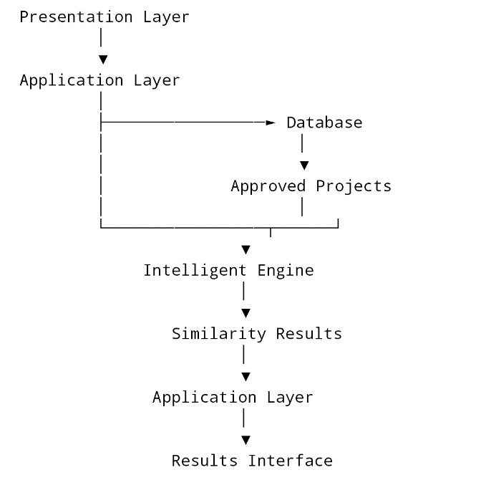
Figure 1 System Architecture

- Repository Management Component
The repository management component is responsible for storing and providing access to final-year undergraduate projects.
Projects submitted by students are initially assigned a pending status. The administrative component was used to review and approve these submissions. Only approved projects are made available through the repository.
The repository is also an important part of the intelligent architecture because the approved projects stored within it constitute the comparison collection used by the originality analysis component.


- Administrative Component
The administrative component provides authorized administrators with control over repository operations. The administrative interface provides functions for managing the project collection and monitoring relevant system activities.
The major administrative functions include: Viewing pending projects, Approving student project submissions, Uploading repository projects, Managing repository projects, Managing students, Viewing system statistics, and Viewing activity records.

- Database Layer
The database layer provides persistent storage for the structured information used by the system.
SQLite was used as the relational database for the implemented system. The database stores information associated with users, student profiles, faculties, departments, projects, download records, and system activity records.
The major project-related information stored in the database includes:
Project title, Author, Supervisor, Faculty, Department, Academic session, Keywords, Abstract, Project document reference, Approval status, and Upload date.
Relationships between the entities allow project records to be associated with their authors, faculties, and departments.
The database also stores the information required by the intelligent component to retrieve approved projects for comparison.

- Project Document Storage
Project documents are handled separately from the structured database information.
The system uses Django's media-file handling mechanism to store uploaded project documents. The database maintains the reference to the uploaded document while the actual document is stored within the configured media storage location.
This separation allows structured project information to remain in the database while potentially larger project documents are managed through file storage.
When an authorized student requests a project download, the application retrieves the corresponding project document and provides it to the user.

- Intelligent Analysis Component
The intelligent analysis component forms the major intelligent feature of the proposed system. Its purpose is to compare a proposed final-year project with approved projects available in the repository and identify the degree of textual similarity.
The component receives the following information from the proposed project: Title, Keywords, and Abstract.
It then compares these fields with corresponding information from approved repository projects.
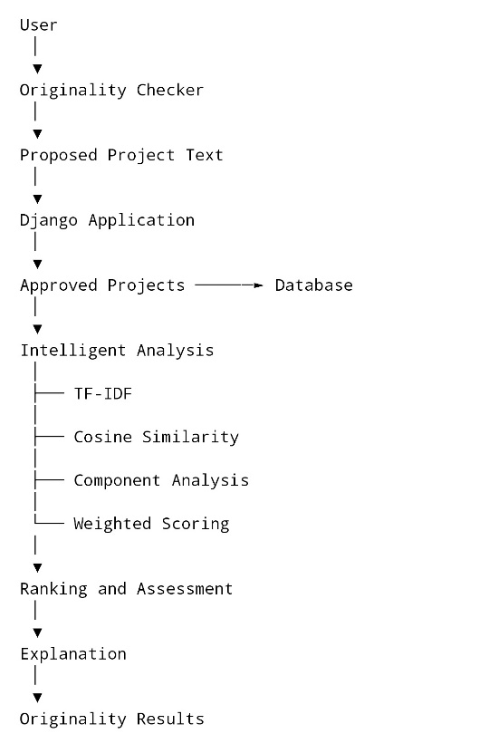
Figure 2 Originality Checker Framework

3.5 Tools and Technologies
The following tools and technologies were used in the development of the proposed system.
- Python
Python was used as the primary programming language for the backend development of the system. Its use supports the implementation of Django and the intelligent similarity analysis.
- Django
Django was used as the web application framework. It provides the structures required for URL routing, request handling, database interaction, authentication, form processing and template rendering.
The system was organized into Django applications, including the accounts, repository and dashboard components.
- HTML
HyperText Markup Language (HTML) was used to define the structure of the system's web pages. It was used for pages such as the home page, login page, registration page, dashboard, repository, project details, upload page, and originality checker.
- CSS
Cascading Style Sheets (CSS) was used to control the appearance and layout of the web interface. It provides styling for navigation areas, forms, buttons, project cards, result displays and other interface components.
- JavaScript
JavaScript was used for client-side interactions. One major application is the dynamic loading of departments after a faculty is selected during project-related form operations.
The JavaScript code sends a request to the Django endpoint for the selected faculty and dynamically updates the department selection.
- SQLite
SQLite was used as the relational database management system for the developed application. It stores user information, student profiles, faculty and department information, project records, download history and activity records.
SQLite was selected for the development prototype because it integrates directly with Django and does not require a separate database server.
- Scikit-learn
Scikit-learn was used to implement the similarity analysis. Specifically, its TF-IDF vectorisation and cosine similarity functions are used by the intelligent component.
- Visual Studio Code
Visual Studio Code was used as the primary development environment for writing and managing the source code.

CHAPTER 4

IMPLEMENTATION, TESTING AND RESULTS

4.1 Introduction
This chapter presents the implementation of the proposed Intelligent Repository System developed for enhancing originality in final-year undergraduate projects. The implementation was carried out based on the system design, requirements, methodology, and architecture presented in the preceding chapters. The implemented system provides a centralized repository for storing, managing, searching, viewing, and retrieving approved final-year undergraduate projects.
The system was developed as a web-based application using the Django web framework. It provides separate functions for students, general repository visitors, and administrators. Students can register, authenticate, submit projects, view their project status, access approved projects, and maintain a record of downloaded projects. Repository visitors can search and view approved projects, while registered users can download project documents. Administrators are responsible for managing submitted projects, approving student submissions, uploading repository projects, managing students, and monitoring repository activities.
A major component of the implementation is the intelligent originality analysis feature. The feature compares a proposed project with approved projects stored in the repository. Term Frequency-Inverse Document Frequency (TF-IDF) was used to represent textual information, while cosine similarity was used to determine the degree of textual similarity between projects. The system further performs component-level comparison using the project title, keywords, and abstract. Weighted similarity scores are then calculated to give greater importance to the title, keywords, and abstract. The results are ranked and presented together with an explanation of the area contributing most strongly to the detected similarity.

4.2 System Implementation And Testing
The proposed system was implemented as a web-based application using a combination of frontend technologies, backend technologies, database management, file storage. The implementation was organized into functional components to ensure that the different activities of the system could work together as a single repository platform.
The implementation consists of the user interface, authentication and authorization, project submission, project approval, repository management, project retrieval, download management, and intelligent originality analysis components.
- User Registration And Authentication
The registration and authentication component provides controlled access to student-specific functions of the system. A student is required to create an account before accessing functions such as project submission and project downloading.
During registration, the system collects the required student information, including the student's personal details, matriculation number, faculty, department, and account credentials. The student's account information is stored in the database, while additional academic information is maintained through the student profile.
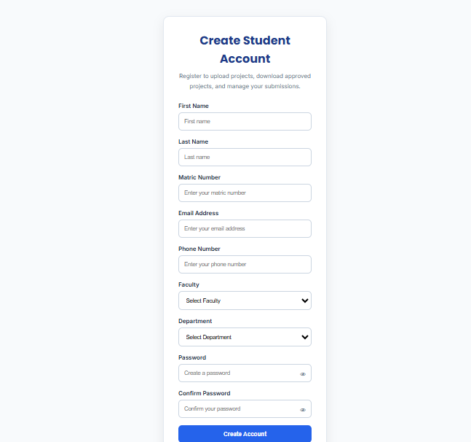
Figure 3 Students Registration Page
The system implements authentication using Django's built-in authentication facilities together with a custom authentication backend. The custom authentication mechanism allows a registered student to log into the system using either the registered email address or matriculation number together with the account password.
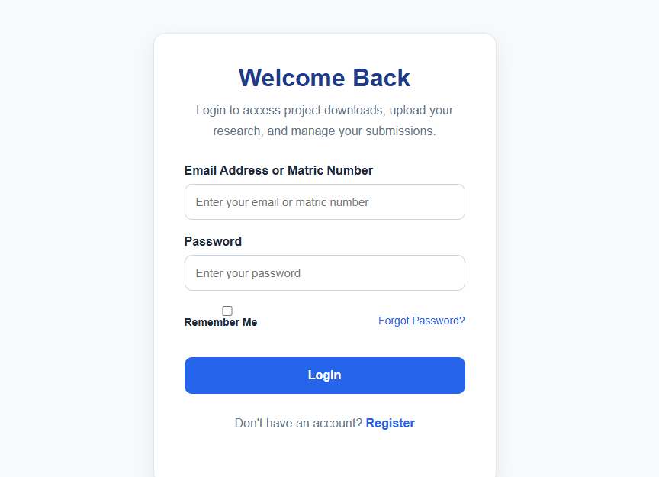
Figure 4 Students Login Page
After successful authentication, the student is redirected to the student dashboard. Access to protected functions is controlled using Django authentication decorators and access-control mechanisms. This prevents unauthenticated users from directly accessing student-specific functions.
- Student Dashboard
The student dashboard provides a centralized interface through which an authenticated student can access major student-related functions.
The dashboard displays information concerning the student's project activities. These include the number of projects uploaded by the student, approved projects, pending projects, and recorded downloads where applicable.
From the dashboard, the student can navigate to functions such as: Upload Project, Repository, Download History, Profile and Project-related activities.
The dashboard therefore serves as the main control point for authenticated student activities within the system.
The implementation also allows the system to distinguish between projects that have been submitted and projects that have received administrative approval. This provides the student with information about the current status of submitted projects.
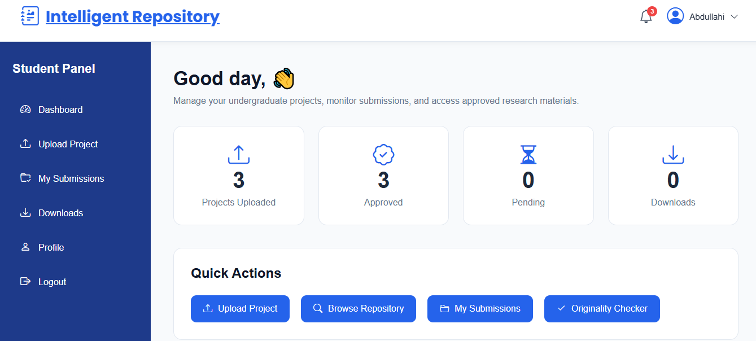
Figure 5 Student Dashboard
- Project Submission
The project submission component allows authenticated students to submit their final-year undergraduate projects to the repository.
The project upload form collects relevant project information including:
Project title, Faculty, Department, Supervisor, Academic session, Keywords, Abstract, and Project document.
When a student submits a project, the system associates the project with the authenticated student's account. The project is initially assigned an unapproved status. This means that the project does not immediately become available in the public repository. The project is reviewed and approved by the admin before it is available in the repository.
This approval-based process helps ensure that projects submitted by students are reviewed before they become part of the approved repository collection.

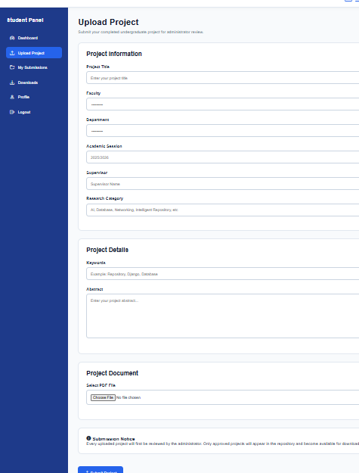
Figure 6 Project Submission Page

- Project Approval and Administration
The administrative component provides authorized administrators with tools for managing the repository and controlling the availability of submitted projects.
When a student submits a project, the project is placed in a pending state. An administrator can access the pending projects section and review the submitted project. Approved projects are then made available in the repository.
Administrator access is restricted using Django's staff-member authorization mechanism. This prevents ordinary users from accessing administrative functions.
The administrator can also upload existing projects directly into the repository. Projects uploaded through the administrative repository-upload function can be approved as part of the upload process. This supports the initial population and continued maintenance of the repository.

Figure 7 Project Approval Page
- Repository Search and Project Management
The repository displays projects that have received administrative approval. Users can search the repository using textual information associated with projects. The implemented search function checks the project title, keywords, and abstract against the search query.
When a search query is provided, the system filters the approved project records and returns projects containing matching information. The resulting projects are displayed through the repository interface.
The repository provides a centralized alternative to manually searching through physical or independently stored project documents.
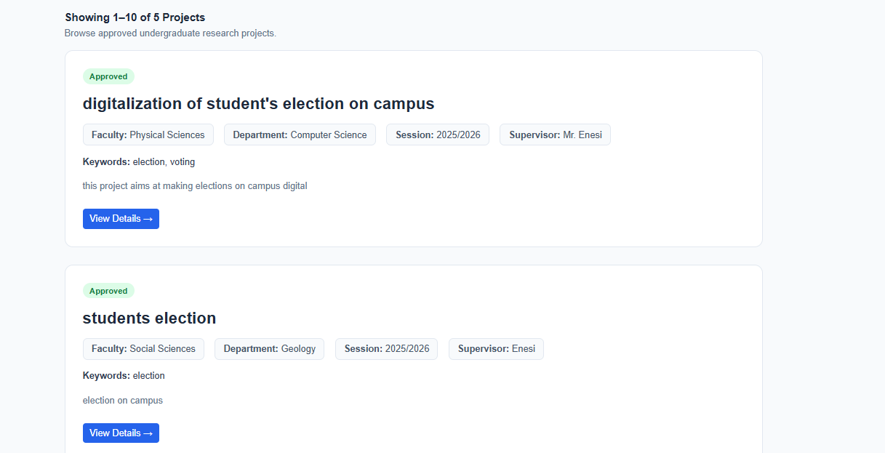
Figure 8 Repository View

- Project Viewing
The project viewing component provides detailed information about individual approved projects. When a user selects a project from the repository, the system displays the project's relevant information. This includes the project title, author, faculty, department, supervisor, academic session, keywords, abstract, and the project document.
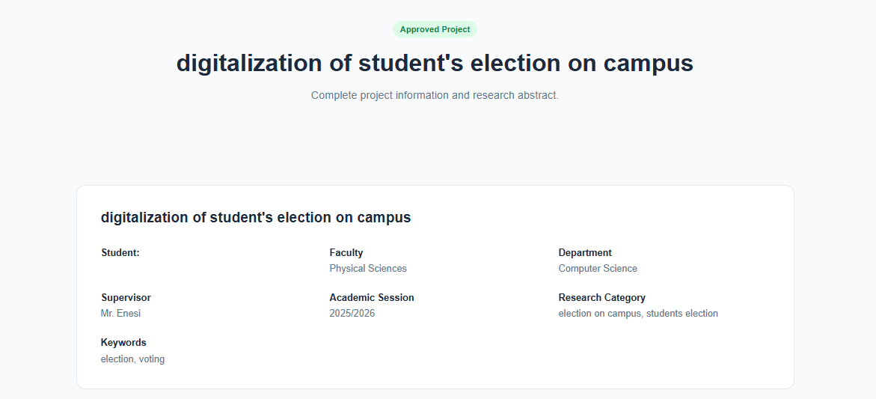
Figure 9 Project View Page
.
- Intelligent Originality Analysis
The intelligent originality analysis component is the major intelligent feature of the proposed system. It was implemented to assist students in identifying textual similarity between a proposed project and projects already approved and stored in the repository.
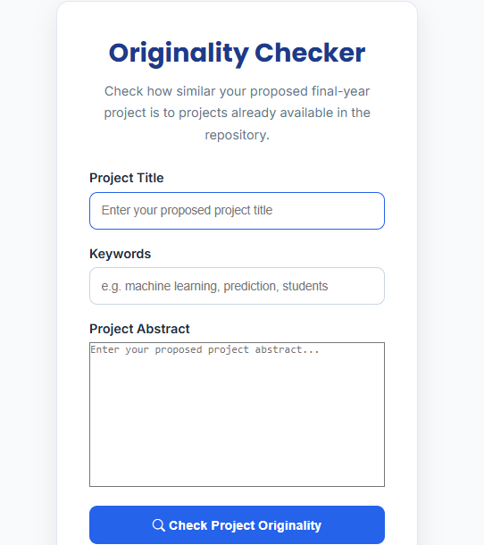
Figure 10 Originality Checker`
These components are combined to form the proposed project text. The system then retrieves projects that have been approved and stored in the repository. Only approved repository projects are considered during the comparison.
The overall similarity process consists of the following stages:
Proposed Project Information → TF-IDF Representation → Cosine Similarity → Similarity Ranking → Component Analysis → Weighted Similarity → Assessment and Explanation
The implementation uses the Scikit-learn library for the text-processing operations.
- TF-IDF Text Representation
Term Frequency-Inverse Document Frequency (TF-IDF) was used to convert project text into numerical vectors that can be compared computationally.
The implementation combines the title, keywords, and abstract of each repository project into a single textual representation. The proposed project is processed in the same manner.
The resulting TF-IDF vectors provide the numerical representation required for calculating textual similarity.
- Cosine Similarity
After the project texts have been transformed into TF-IDF vectors, cosine similarity was used to determine the degree of similarity between the proposed project and each approved repository project.
The system calculates an overall similarity percentage for each approved repository project. The projects are then arranged according to their similarity scores so that the projects with the strongest textual similarity appear first.
- Component-Level Similarity Analysis
In addition to the overall similarity calculation, the system performs a separate comparison of individual project components.
Each component is compared with the corresponding component of an existing repository project. This allows the system to identify the particular part of a proposed project that contributes most strongly to the detected similarity.
- Weighted Similarity Calculation
The system uses weighted similarity to combine the component-level scores into an overall project similarity score.
The implemented weighting scheme assigns:
Title — 35%
Keywords — 20%
Abstract — 45%
The weighted score is calculated from the component similarity values. The use of different weights allows the system to give greater influence to components considered more informative for textual comparison. The weighted score is subsequently used to rank the repository projects presented in the originality analysis results.
- Similarity Assessment and Explanation
After calculating the weighted similarity scores, the system determines an overall similarity level based on the highest similarity score obtained from the repository comparison.
The implemented assessment levels are:
Low Similarity, Moderate Similarity, or High Similarity.
The thresholds implemented in the system classify scores below 40% as low similarity, scores from 40% to below 70% as moderate similarity, and scores of 70% or above as high similarity.
The system also generates an explanation of the strongest similarity area for each compared project. It examines the component-level scores and identifies the component with the highest score. The explanation then informs the user whether the strongest similarity is associated with the title, keywords, or abstract.
- Integration of the Implemented Components
The different components of the system were integrated into a single web-based application. The frontend provides the interfaces through which users interact with the system, while the Django backend processes requests, manages authentication, communicates with the database, handles project files, and executes the intelligent similarity functions.
This integration allows repository management and intelligent originality analysis to operate within the same application rather than as independent systems.
The implemented system therefore provides a complete workflow in which projects can be submitted, reviewed, approved, stored, searched, viewed, and downloaded, while proposed projects can also be compared against the approved repository collection to identify areas of textual similarity.

4.3 System Utility
The developed system provides utility to different categories of users.
For students, the system provides a mechanism for finding previous projects, submitting projects, retrieving approved project documents, maintaining download records, and checking the textual similarity of proposed project ideas.
For administrators, the system provides functions for approving submitted projects, uploading repository content, managing students, monitoring activities, and maintaining the repository.
For repository users, the system provides searchable access to approved final-year undergraduate projects.
The originality analysis component provides an additional utility by allowing proposed project ideas to be compared against the existing repository collection before the project is fully developed.
The system therefore combines repository management and similarity analysis within a single application.

4.4 System Strengths
The major strengths identified from the implementation include the following:
i. Centralized project repository: Previous projects can be maintained within a single system.
ii. Search functionality: Users can search project information using relevant textual terms.
iii. Administrative approval: Student submissions require administrative approval before becoming approved repository content.
iv. Controlled access: Authentication was used for student-specific operations such as project submission and downloading.
v. Intelligent similarity analysis: Proposed projects can be compared automatically against approved repository projects.
vi. Component-level analysis: Similarity is examined separately across the title, keywords, and abstract.
vii. Weighted similarity: Different project components contribute differently to the final similarity score.
viii. Similarity explanation: The system identifies the component with the strongest detected similarity.
ix. Integrated web interface: Repository management and originality analysis are provided within the same web application.
These features allow the system to support both conventional repository functions and the project's intended originality-enhancement objective.

CHAPTER 5

SUMMARY, CONCLUSION, AND RECOMMENDATION

5.1 Summary
The study focused on the development of an intelligent repository system for enhancing originality in final-year undergraduate projects. The motivation for the study was based on the need for a centralized platform through which previous undergraduate projects could be stored, searched, accessed, and used as reference material when developing new project ideas.
The first stage of the study involved identifying the requirements of the proposed system. The requirements were used to determine the major functions required by students, repository users, and administrators. The identified requirements included user registration and authentication, project submission, project approval, repository search, project viewing, project downloading, download history, administrative management, and originality analysis.
A web-based system was subsequently designed to implement these requirements. The system was developed using Django as the backend web framework, Python as the programming language, SQLite as the database, and HTML, CSS, and JavaScript for the user interface. Scikit-learn was incorporated into the system to provide the text-processing functions required for the intelligent similarity analysis.
The repository component was implemented to allow approved final-year projects to be stored and retrieved through a centralized platform. Students can register and authenticate using their email address or matriculation number. Authenticated students can submit projects containing information such as the title, faculty, department, supervisor, academic session, keywords, abstract, and project document.
Submitted student projects are initially placed in a pending state. An administrator can review the submitted projects and approve them before they become available in the repository. Administrators can also upload projects directly into the repository, manage repository records, manage students, view statistics, and monitor system activities.
The repository provides search functionality based on textual information associated with stored projects. Users can access approved project information through the project details interface.
The major intelligent feature of the system is the originality analysis component. The component was developed to compare a proposed project against approved projects available in the repository. The proposed project is represented using its title, keywords, and abstract. These textual components are processed using Term Frequency-Inverse Document Frequency (TF-IDF), while cosine similarity was used to determine the degree of textual similarity between the proposed project and existing repository projects.
The intelligent component was further extended to perform component-level similarity analysis. Instead of relying only on an overall similarity score, the system separately analyses the title, keywords, and abstract. The resulting component scores are combined using a weighted similarity calculation. The similarity results are ranked so that projects with higher similarity scores are presented first. The system also provides an assessment of the highest similarity level and generates an explanation identifying the project component that contributed most strongly to the detected similarity.
The implemented originality checker is repository-based. It compares proposed projects against approved projects available within the developed repository. It is therefore intended to assist students in identifying potentially related previous projects rather than serving as a universal plagiarism detection system.
Overall, the developed system integrates conventional repository management functions with an intelligent textual similarity component within a single web-based application.

5.2 Conclusion
The development of the Intelligent Repository System has demonstrated the feasibility of combining a centralized undergraduate project repository with an intelligent textual similarity analysis mechanism.
The developed system provides a structured platform for storing and accessing previous final-year undergraduate projects. Through the project submission and administrative approval process, projects can be introduced into the repository in a controlled manner. The repository search and retrieval functions also provide students with a more structured means of locating previous projects relevant to their proposed areas of study.
The implementation of the intelligent component provides an additional function beyond conventional project repositories. By applying TF-IDF and cosine similarity to project information, the system can identify textual relationships between a proposed project and projects already available in the repository. The component-level analysis further allows users to determine whether the strongest similarity is associated with the title, keywords, or abstract.
The weighted similarity mechanism and explanatory results provide additional information that can assist students when reviewing their proposed project ideas. Rather than simply returning a list of existing projects, the system provides similarity scores and identifies the area in which the strongest textual similarity occurs.
In relation to the objectives of the study, the system provides a centralized repository for final-year undergraduate projects, supports controlled submission and approval, provides project search and retrieval functions, and implements an intelligent repository-based similarity analysis mechanism. These functions collectively support the intended purpose of helping students identify related previous projects before proceeding with their proposed work.
The developed system consequently provides a practical foundation for improving the management and use of previous undergraduate projects while introducing an intelligent mechanism for supporting originality assessment within the repository environment.

5.3 Recommendation
Based on the implementation and limitations identified during the study, the following recommendations are made for further development and use of the system.
- Expansion of the Repository
The repository should be continuously expanded with properly approved final-year undergraduate projects from different departments and academic sessions. A larger and more diverse repository would provide a broader collection of projects against which proposed projects can be compared.
- Improvement of Intelligent Similarity Analysis
Future development could extend the similarity engine beyond the current textual fields of title, keywords, and abstract. Additional sections of project documents could be processed to provide a broader comparison.
The intelligent component could also be enhanced with other Natural Language Processing techniques capable of recognizing semantic relationships between texts rather than relying primarily on word-level TF-IDF representations.
- Source-Code Similarity Analysis
Since many final-year Computer Science projects involve software development, future versions could include source-code similarity analysis. Such a feature could compare programming structures and source-code patterns between projects in addition to natural-language text.
This would extend the originality assessment beyond written project descriptions.
- External Repository and Web Comparison
Future versions could provide controlled comparison with additional academic repositories or other approved external sources. Such an extension would reduce the limitation created by relying only on projects stored within the developed repository.
Any external comparison mechanism should, however, consider copyright, privacy, access permissions, and institutional policies governing academic documents.
- Improved Administrative Monitoring
The administrative component could be expanded with more detailed reporting and monitoring functions. This may include project submission trends, departmental project statistics, similarity-analysis statistics, and other repository usage information.
- Mobile and Responsive Enhancement
The user interface could be further optimized for mobile devices to improve accessibility for students who primarily access the system through smartphones and tablets.
- Continuous Maintenance and Evaluation
The system should be periodically maintained and evaluated as the repository grows. New projects, departments, faculties, and academic sessions should be incorporated into the system as required. The intelligent component should also be evaluated periodically to determine whether its similarity results remain useful as the size and nature of the repository change.

REFERENCES
Lynch, C. A. (2003). Institutional repositories: Essential infrastructure for scholarship in the digital age. portal: Libraries and the Academy, 3(2), 327-336.
Django Software Foundation. (2026). Django documentation (Version 6.0). https://docs.djangoproject.com/en/6.0/
Foltýnek, T., Meuschke, N., & Gipp, B. (2019). Academic plagiarism detection: A systematic literature review. ACM Computing Surveys, 52(6), Article 112, 1–42. https://doi.org/10.1145/3345317
Manning, C. D., Raghavan, P., & Schütze, H. (2008). Introduction to information retrieval. Cambridge University Press. https://doi.org/10.1017/CBO9780511809071
Python Software Foundation. (2026). Python 3.14.7 documentation. https://docs.python.org/3/
Salton, G., & Buckley, C. (1988). Term-weighting approaches in automatic text retrieval. Information Processing & Management, 24(5), 513–523. https://doi.org/10.1016/0306-4573(88)90021-0
Scikit-learn developers. (2026). Cosine similarity. scikit-learn documentation. https://scikit-learn.org/stable/modules/metrics.html
Scikit-learn developers. (2026). TfidfVectorizer. scikit-learn documentation. https://scikit-learn.org/stable/modules/generated/sklearn.feature_extraction.text.TfidfVectorizer.html
SQLite Consortium. (2026). About SQLite. https://sqlite.org/about.html
Widianto, A., Pebriyanto, E., Fitriyanti, F., & Marna, M. (2024). Document similarity using term frequency-inverse document frequency representation and cosine similarity. Journal of Dinda: Data Science, Information Technology, and Data Analytics, 4(2), 149–153. https://doi.org/10.20895/dinda.v4i2.1589
Smith, M., Bass, M., McClellan, G., Tansley, R., Barton, M., Branschofsky, M., Stuve, D., and Walker, J. H. (2003). DSpace: An open source dynamic digital repository. D-Lib Magazine, 9(1).
Jones, K. S. (1972). A statistical interpretation of term specificity and its application in retrieval. Journal of Documentation, 28(1), 11-21.
Pedregosa, F., et al. (2011). Scikit-learn: Machine learning in Python. Journal of Machine Learning Research, 12, 2825-2830.
Reimers, N., and Gurevych, I. (2019). Sentence-BERT: Sentence embeddings using Siamese BERT-networks. Proceedings of EMNLP-IJCNLP 2019, 3982-3992. (Use to motivate semantic similarity as future work.)
Brooke, J. (1996). SUS: A quick and dirty usability scale. In P. W. Jordan et al. (Eds.), Usability Evaluation in Industry. Taylor and Francis. (Only if you run the usability test.)
Federal Republic of Nigeria. (2023). Nigeria Data Protection Act. (For the data protection recommendation in 5.3.

APPENDIX
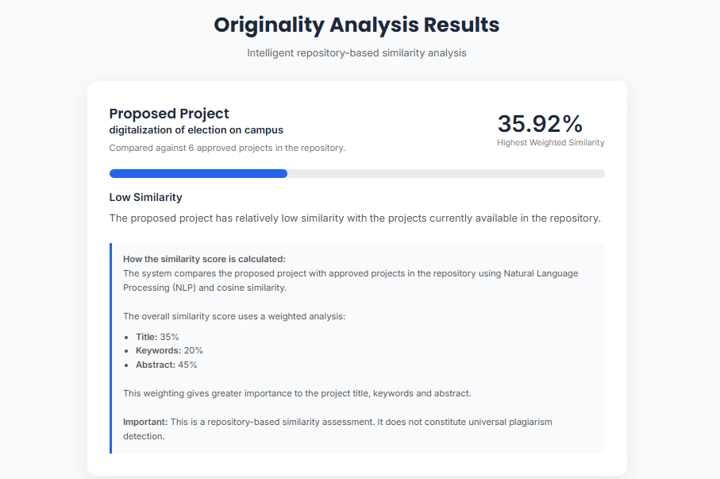
Figure 11 Similarity Check with Low Similarity

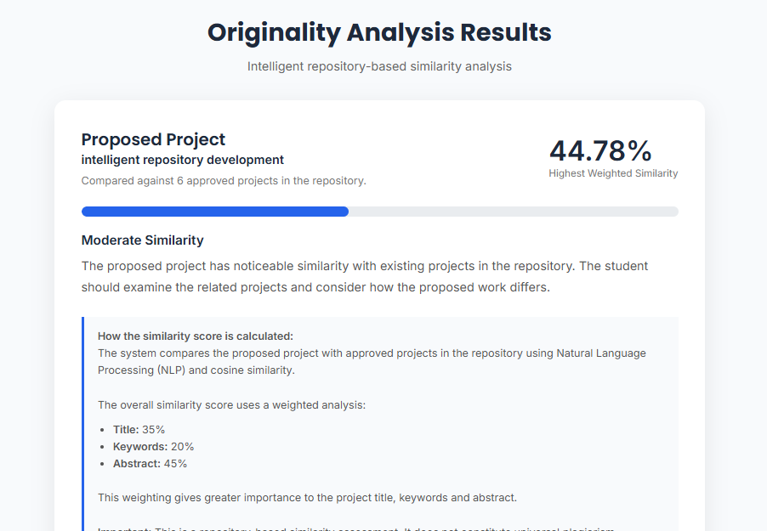
Figure 12 Similarity Check With Moderate Similarity
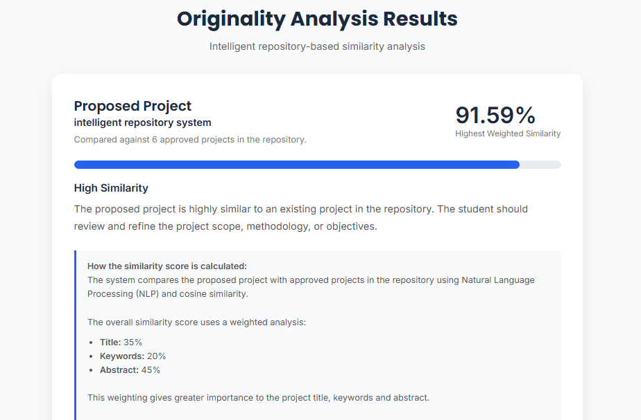
Figure 13 Similarity Check With High Similarity

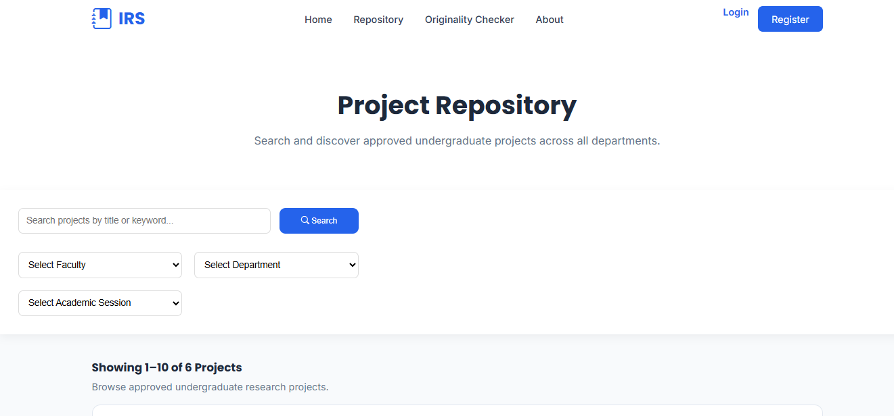
Figure 14 Repository Search

